PRACTICAL 1

AIM:- Use Google & Whois for Reconnaissance.

Tools:- Using Who.is

Step 1: Open the Who.is website.

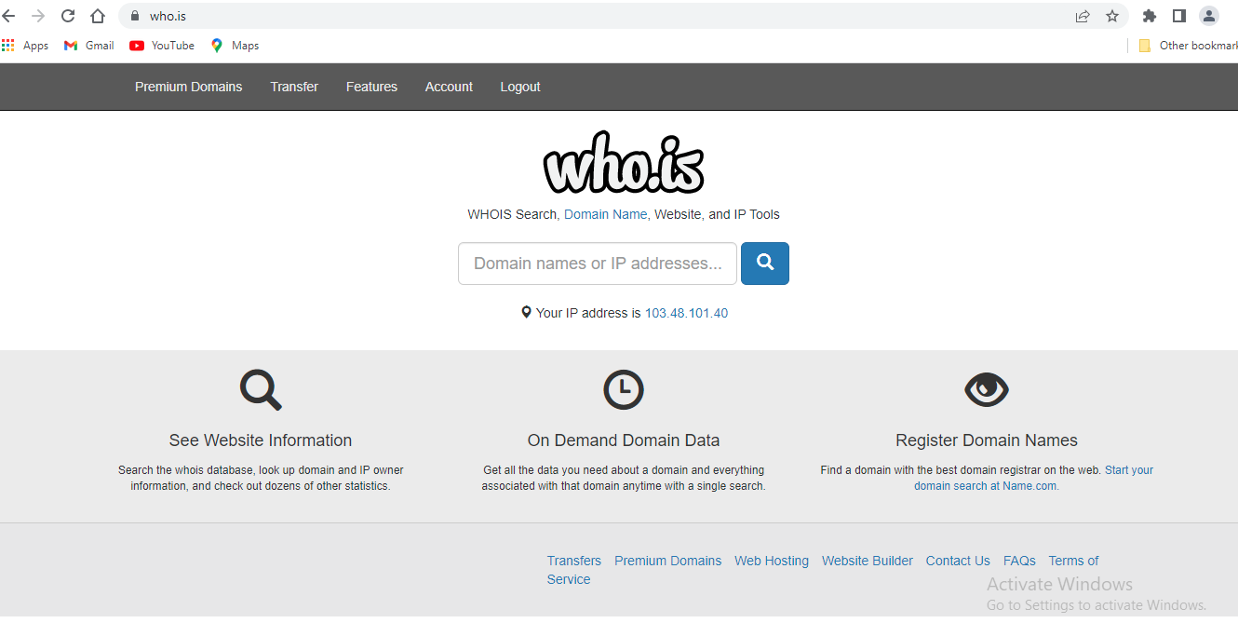

Step2: Enter the website name & hit the “Enter Button”.

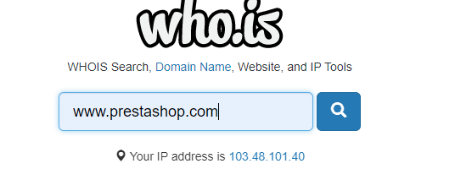

Step3: Show you the information about prestashop.com

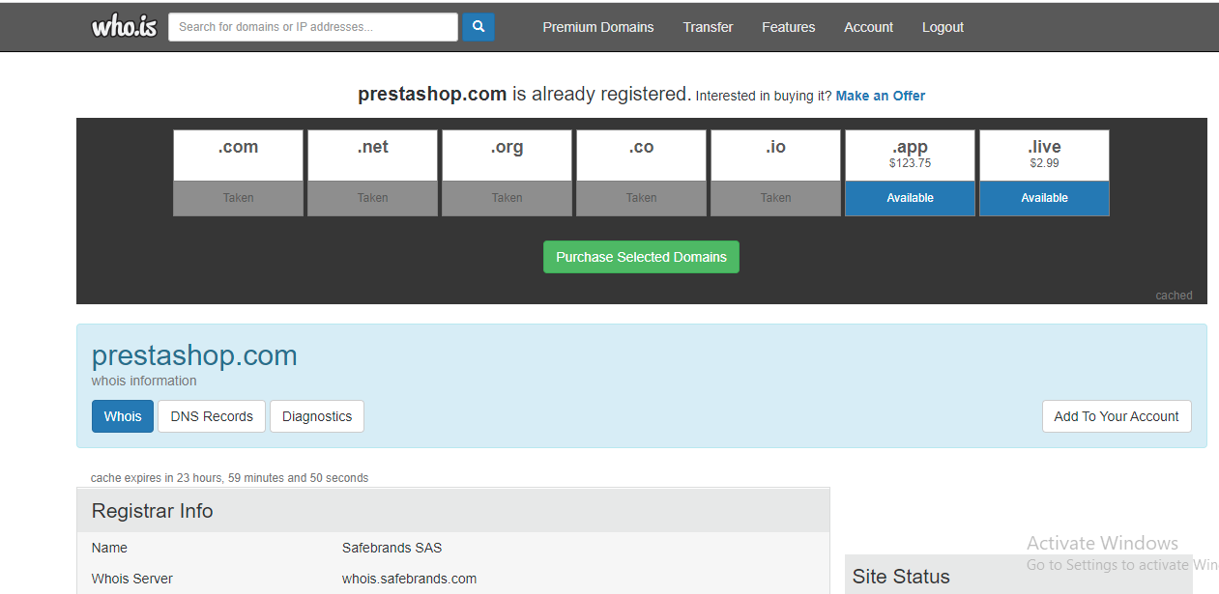

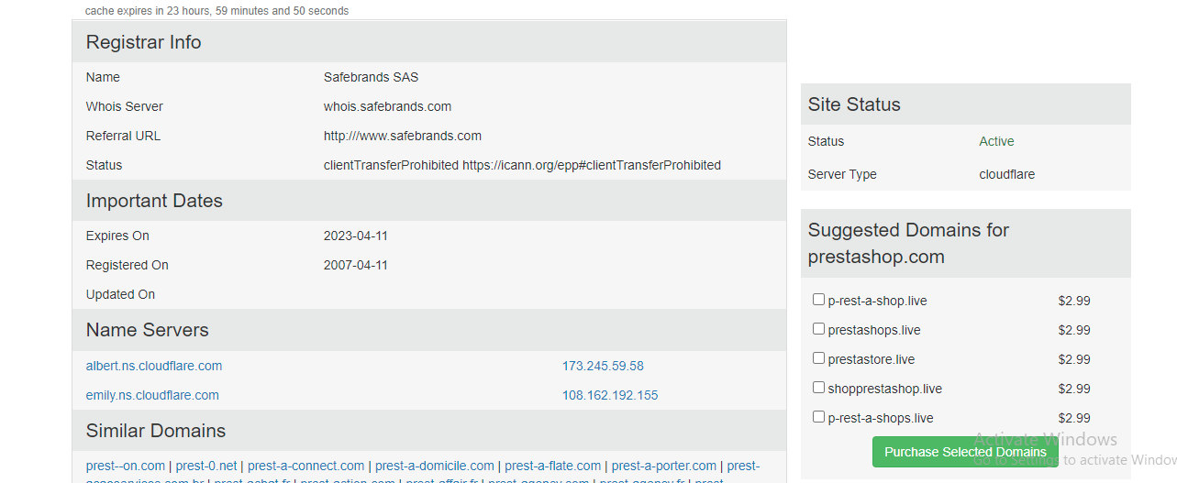

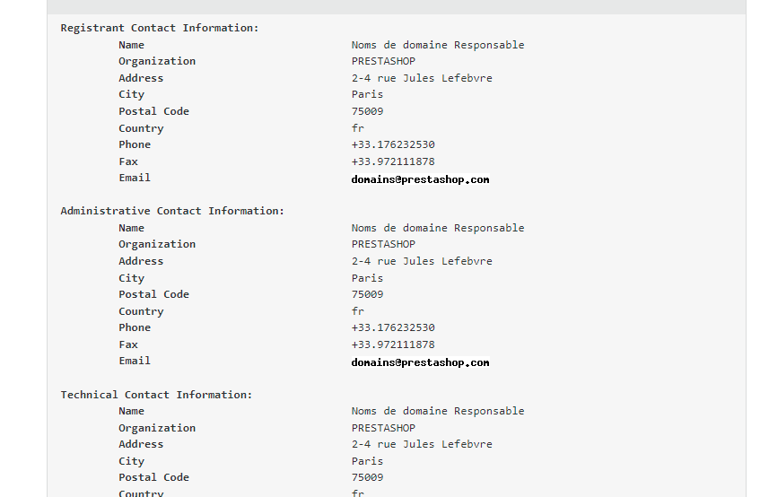

PRACTICAL 4

AIM : Using Nmap scanner to perform port scanning of various forms – ACK, SYN, FIN, NULL, XMAS.

NOTE: Install Nmap for windows and install it. After that open cmd and type “nmap” to check if it is installed properly. Now type the below commands.

* Nmap
* Working of nmap
* Syn scan
* ACK scan (-sA)
* -p
* -T4
* FIN scan (-sF)
* NULL scan (-sN)
* XMAS Scan (-sX)